EAC Region One Zoom Meeting Minutes - February 10, 2026
By Kevin Winn, Region 1 Secretary
EAC Region One held its fifth annual Zoom meeting on February 10nd at 8:00 PM Eastern time.
The meeting was opened by region one Chairman, Tim Skinski, at 8:00. There were twenty-two members present. That was the most attendees ever for one of our annual meetings. Thanks go out to Joe Pergola for helping us set up the Zoom call on his account. The twenty-two attendees were from a total of twelve states including Texas, Missouri, Ohio, South Carolina, and Virginia so this was clearly not just a Region One meeting. Tim and I appreciate the support from all members of the organization.
The agenda included a talk by EAC Convention Bourse Chairman, Jerry Sajbel, about the upcoming 2026 EAC Convention to be held in Charlotte NC., from Wednesday April 29th to Sunday, May 3rd. The Convention will be held at:
Sheraton Charlotte Airport Hotel
3315 Scott Futrell Drive
Charlotte, NC 28208
704-392-1200
Hotel reservations will be made directly with the hotel; on the Group Web Link or by calling 1-800-325-3535. Single and Double room rates are $152/night.
Jerry mentioned that all sixty-four tables in the bourse have been sold and they are now working on sharing tables among dealers to try and get even more vendors access to the event. Jerry also mentioned that there are tables reserved for Early Copper Exhibits, tables for lot viewing for coins in the Saturday night auction, and club tables.
Jerry reviewed the agenda for the entire show which includes a “Boyz of ’94” meeting on Wednesday, a grading seminar taught by Jim Carr on Thursday, the Reception and the Happenings on Thursday, Bourse on Friday through Sunday, the auction on Saturday night and the EAC Annual Meeting on Sunday. There will also be six educational seminars held three per day, on Friday and Saturday. There will be a field trip on Friday to the Old Mecklenburg Brewery where they serve “Copper” beer, and possible side trips to:
- The Whitewater and Raptor Center
- The Federal Reserve building and operation
- The Reed Gold Mine site of the first US gold discovery.
- The Mint Museum in Charlotte

Tim Skinski talked about the half cent Happening which he will be facilitating at the convention on Thursday, April 30th at 8:00 PM. Tim’s selections for the Happening include: 1793 C-4, 1794 C-1B, 1803 C-3, 1804 C-2, 1832 C-1, and 1834 C1. There will also be a Large Cent Happening.
Jack Young talked about his research and writings regarding early copper counterfeits. His columns entitled “Jack Young’s Authenticity Challenged Corner” have been appearing regularly in recent editions of Penny-Wise.
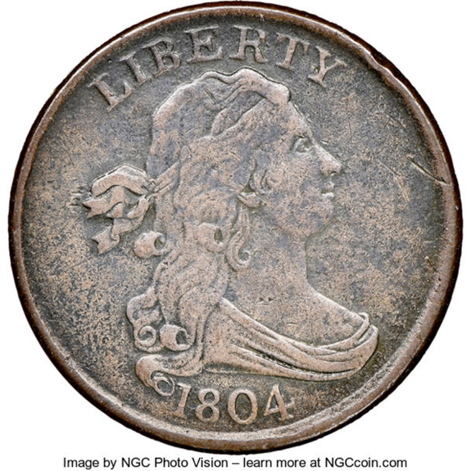
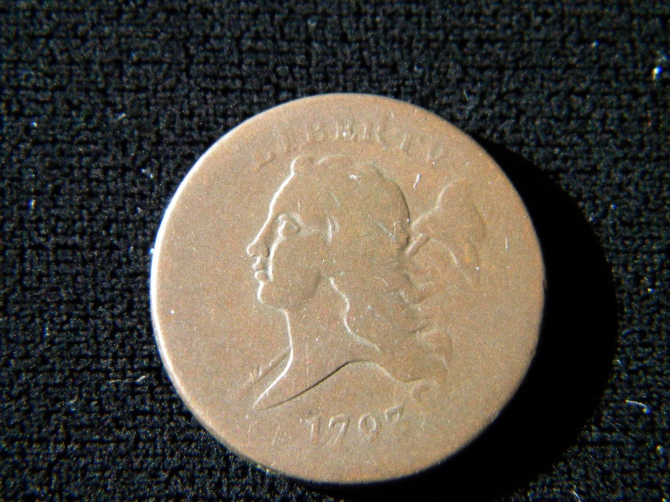
Bob Kebler then took over the meeting to talk about his half-cent collection which has been consigned into the EAC members-only auction at this year’s convention. He had really great slides and stories about some of his favorite coins which will be sold. Those included his 1793 C-1, one of the first half-cents ever produced, a 1797 C-1 made from a Talbot, Allum, and Lee token, and three others with great pedigrees, including an 1804 C-8 “Spiked Chin” which was one of the coins involved in a famous 1985 half-cent trade between Bill Weber and Roger Cohen. (See picture and Provenance below from Bob K.)
1804 C4 Gilbert (Plate Coin)-Commodore W. C. Eaton (sold privately)-“Anderson Dupont” Sale (Stack’s) 11/1954:1074-Philip M. Showers (Stack’s privately 1969)-Willis I. DuPont-R. Tettenhorst-Bill Weber 3/1985-Roger S. Cohen, Jr. (Superior) 2/1992:143-John
Bob Kebler's 1793 C-1 in the EAC Auction.

The meeting was supposed to last one hour but almost everyone had something to say, and it turned into nearly two hours of enjoyable copper discussion when Tim adjourned the session at 9:48 PM.
The next Region One meeting will be an in-person only event (no zoom) on Friday, April 3rd, at 1:30 PM, at the Manchester Coin and Currency Expo.
Respectfully Submitted,
Kevin Winn
EAC Region One Secretary

